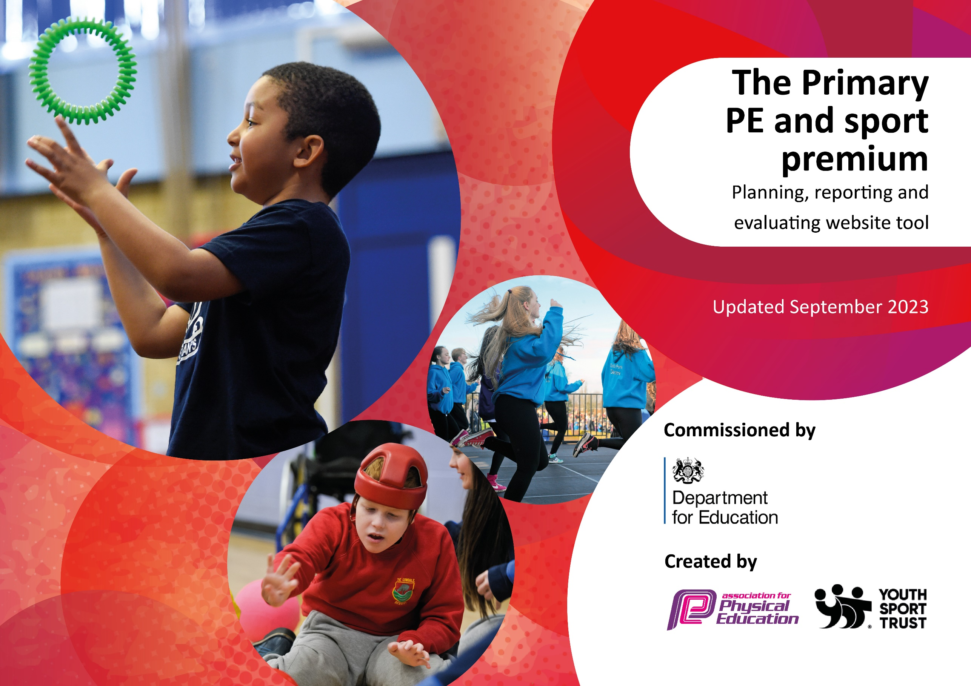

2025-2026

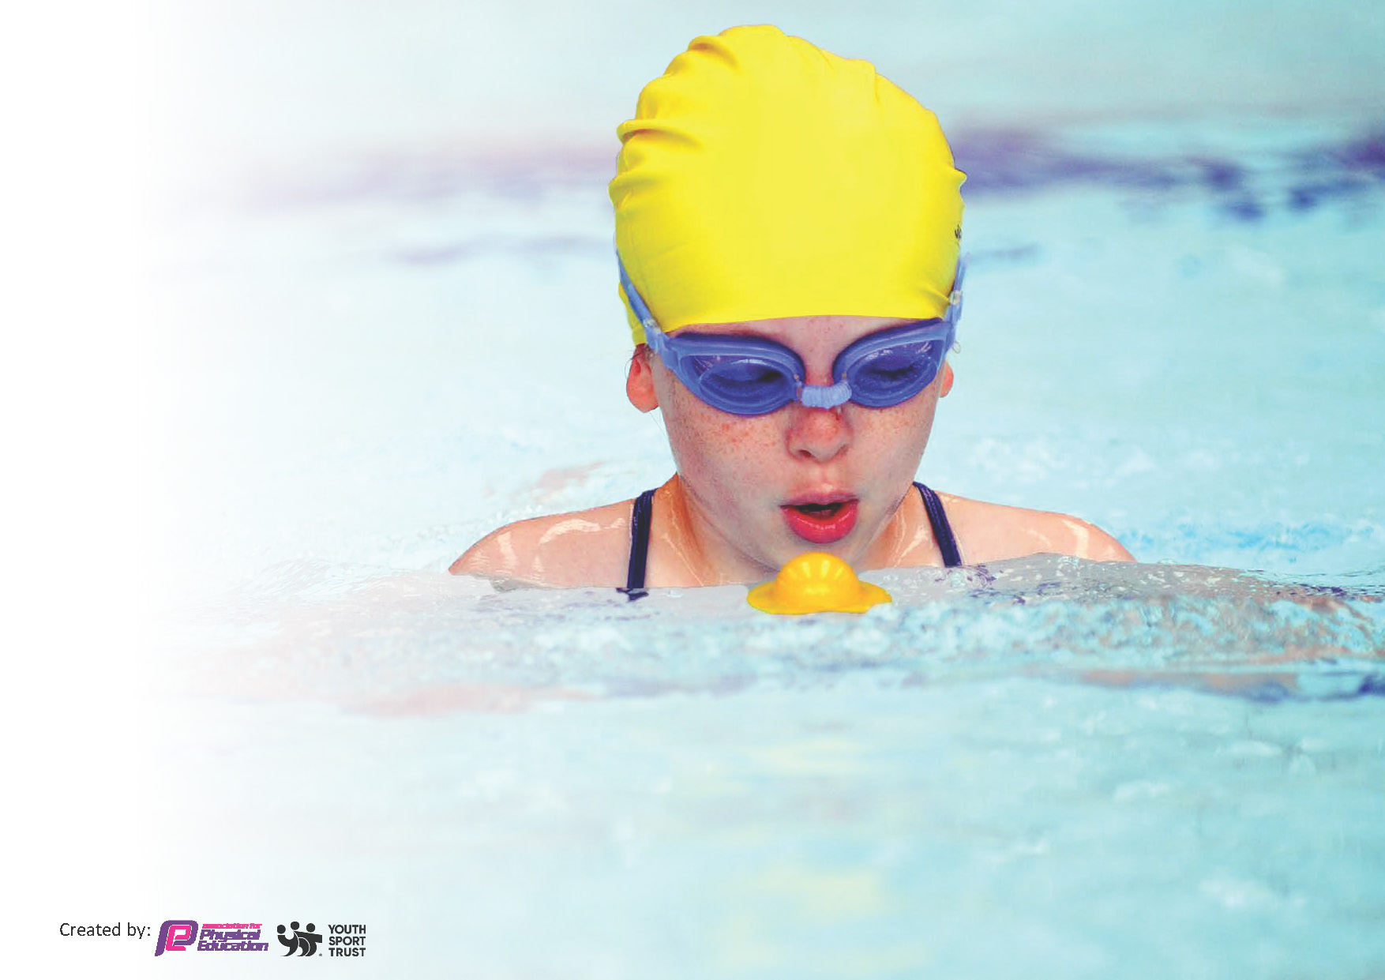
This template can be used for multiple purposes:
by:
- It enables schools to effectively plan their use of the Primary PE and sport premium
- It helps schools to meet the requirements (as set out in guidance) to publish information on their Primary PE and sport premium
- It will be an effective document to support Ofsted inspections enabling schools to evidence progress in Physical Education (PE) and evidence swimming attainment, which forms part of the PE National Curriculum. We would recommend schools consider
the Intent, Implementation and Impact of any spend, as examined within the Education Inspection Framework.

It is important that your grant is used effectively and based on school need.

Schools must use the funding to make additional and sustainable
improvements to the quality of the PE, School Sport and Physical Activity (PESSPA)
they offer. This means that you should use the Primary PE and sport premium to:

- Build capacity and capability within the school to ensure that improvements made now will benefit pupils joining the school in future years
- Develop or add to the PESSPA activities that your school already offers.

The Primary PE and sport premium should not be used to fund capital spend projects; the school’s core budget should fund these. Further detail on capital expenditure can be found in the updated Primary PE and sport premium guidance.

The Primary PE and sport premium guidance, outlines 5 key priorities that funding should be used towards. It is not

necessary that spending has to meet all the key priorities, you should select the priorities that you aim to use any funding towards.

Although completing this template is not a requirement for schools, schools are required to publish details of how they spend this funding. Schools must also outline what the impact this funding has had on pupils’ PE and sport participation and attainment and how any spending will be sustainable in the future.

The Department for Education has worked closely with the Association for Physical Education (afPE) and the Youth Sport Trust (YST) to develop this template and encourages schools to use it. This template is an effective way of meeting the reporting requirements of the Primary PE and sport premium.

Key priorities and Planning
This planning template will allow schools to accurately plan their spending.

Action – what are you planning to do | Who does this action impact? | Key indicator to meet | Impacts and how sustainability will be achieved? | Cost linked to the action
Purchase a license for Complete PE’s scheme of work for Foundation, KS1 and KS2.  Hire a specialist PE coach to further improve the quality of our PE, School Sport and Physical Activity offer.  Continue to develop ‘Sports Leaders’, whose role will include running lunch clubs targeted at KS2 children (including all Pupil Premium children), running and officiating the World Cup league and having key jobs at Sports Day.  Purchase new equipment to increase the breadth and depth of provision in PE lessons and after school clubs.  Children will be as physically active as possible throughout the week. 1 hour is to be timetabled every week per class with either the PE lead or PE coach (both subject specialists). A second hour of physical education activities will be accessible for all through the open provision and activities available during break and lunchtimes and after school.  Take part in numerous School Sport Nottingham ‘Competitions’, ‘Festivals’, ‘Participations’ and ‘Inclusion’ events.  Take part in Transform Trust events.  Conduct pupil voice to enable us to provide a tailored curriculum and open provision and extra-curricular clubs meeting our children’s needs.  Hire taxis/minibus to increase our capacity to transport children to inter school events.  To reintroduce the school football team.  To upskill class teachers with their teaching of PE through a staff inset that will focus on STEP, Whole-Part-Whole and Danish Longball. The current model means most teachers don’t teach PE. For longevity, and the unknown in regards to the Olympic Legacy money, teachers need to start teaching PE again. | Teachers and PE coach  Children.  KS2 children  All children  Children, teaching staff, PE specialist and midday supervisors  Year 1-6 children  Years 2-6  Children, PE lead and PE coach and midday supervisors  Children from years 1-6  Children from years 4-6.  All staff. | Key Indicator 1: Increased confidence, knowledge, and skills of all staff in teaching PE and sport  Key Indicator 2: The engagement of all pupils in regular physical activity  Key Indicator 5: Increased participation in competitive sport  Key Indicator 2: The engagement of all pupils in regular physical activity  Key Indicator 3: Raising the profile of PE and sport across the school, to support whole school improvement  Key Indicator 4: Offer a broader and more equal experience of a range of sports and physical activities to all pupils  Key Indicator 4: Offer a broader and more equal experience of a range of sports and physical activities to all pupils  Key Indicator 2 - Engagement of all pupils in regular physical activity  Key indicator 5: Increased participation in competitive sport  Key indicator 5: Increased participation in competitive sport.  Key Indicator 4 - Broader experience of a range of sports and activities offered to all pupils  Key indicator 5: Increased participation in competitive sport.  Key Indicator 3: Raising the profile of PE and sport across the school, to support whole school improvement  Key Indicator 4 - Broader experience of a range of sports and activities offered to all pupils  Key indicator 5: Increased participation in competitive sport  Key Indicator 1: Increased confidence, knowledge, and skills of all staff in teaching PE and sport  Key Indicator 2: The engagement of all pupils in regular physical activity | The Complete PE scheme of work allows teachers to easily and clearly see how to progress physical literacy within a PE lesson; this can then be applied to their practice.  Progressive teaching of physical literacy occurs within and between year groups, due to the coherent and well-sequenced scheme of work both the PE lead and coach follows. PE lead and coach will continue to teach using Complete’s scheme, building on prior teaching and learning. Assessments are completed on this, too.  Children benefit by being taught by a PE specialist.  Provision during school and physical activity extra-curricular clubs (run by the PE coach) to engage more pupils in exercise and healthy movement.  The PE coach provides a much wider range of sports-specific after school clubs.  Select Y3-6 children to act as advocates of the power of PE and school sport, as well as developing their leadership skills while helping to make Robert Shaw a more physically active school. Children to take part in sports and, increasing the reach of our physical activity programme at break and lunch times.  Children in all year groups can take part in an increased and wider variety of activities/sports, both in curriculum time and extra-curriculum time.  The equipment is used year on year, with additional purchases continuing to be made on a need basis (following annual audit).  More children participating in physical activity and meeting the suggested amount. The open-provision will be built on each year, keeping the activities that work well and altering those that need it.  More children get to compete in inter-school sports events (at competition level), providing a wealth of opportunities to apply learning from after-school clubs. More children get to compete in inter school sports events (at festival and participation level), providing a wealth of opportunities to apply learning from lessons.  More children get to compete in inter-school sports events.  Children will receive activities that they showed an interest in. This will help shape out curriculum and open-provision, going forwards.  A wider variety of pupils have positive experiences of competition, so take part in even more sports events as they grow older.  A range of children from years 4-6 have participated in fixtures off-site. Again, a wider variety of pupils have positive experiences of competition, so take part in even more sports events as they grow older.  From next academic year, teachers will teach Danish Longball to their class and run an intra-league with their partner teachers (children expressed through pupil voice a desire for more competitive opportunities in school). Through teachers filling in the timetable, the PE lead will be able to check-in and see the impact of the training he led. This target also helps in children achieving the recommended weekly physical activity. | £525  £16, 760  N/A  £945  N/A  £400  N/A  N/A  £480  £480  N/A

Key achievements 2025-2026
This template will be completed at the end of the academic year and will showcase the key achievements schools have made with their Primary PE and sport premium spending.

Activity/Action | Impact | Comments
13 School Sport Nottingham competitions entered.  2 Transform Trust event entered.  Extra-curricular clubs  Re-introduce school football team  Achieved Silver in the School Games Mark | Key Indicator 4: Broader experience of a range of sports and activities offered to all pupils  Key indicator 5: Increased participation in competitive sport.  Key Indicator 4: Broader experience of a range of sports and activities offered to all pupils  Key indicator 5: Increased participation in competitive sport.  Key Indicator 4: Broader experience of a range of sports and activities offered to all pupils  Key indicator 5: Increased participation in competitive sport.  Key Indicator 4: Broader experience of a range of sports and activities offered to all pupils  Key indicator 5: Increased participation in competitive sport.  Key Indicator 2: The engagement of all pupils in regular physical activity  Key Indicator 3: Raising the profile of PE and sport across the school, to support whole school improvement  Key Indicator 4: Offer a broader and more equal experience of a range of sports and physical activities to all pupils  Key indicator 5: Increased participation in competitive sport | Children from years 1-6 participated in numerous School Sport Nottingham ‘Competitions’, ‘Festivals’, ‘Participations’ and ‘Inclusion’ events.  Children from years 5-6 participated in a Trust event.  3 extra-curricular clubs a week have ran for the entire year for children from years 1-6.  Children from years 4-6 participated in the NSFA league, off-site.  The school achieved silver, comfortably, and were at the gold level in many areas.

Swimming Data
Meeting National Curriculum requirements for swimming and water safety.
Priority should always be given to ensuring that pupils can perform safe self-rescue even if they do not fully meet the first two requirements of the National Curriculum programme of study

Question | Stats: | Further context  Relative to local challenges
What percentage of your current Year 6 cohort can swim competently, confidently and proficiently over a distance of at least 25 metres? | 15% | We used to have a swimming pool within walking distance, now we don’t. We use a coach to take us there are back. This takes up time but more significantly a lot of the budget. Our children of from backgrounds where swimming is not something they generally do. This gives us the task of trying to get a lot of complete non-swimmers swimming 25 metres. A lot of the children have barely been in a swimming pool before.
What percentage of your current Year 6 cohort can use a range of strokes effectively [for example, front crawl, backstroke, and breaststroke]? | 25% | We have a higher percentage of children able to use a variety of strokes effectively. However, even though we have more achieving this, they are not able to use them across the required 25-metre distance.

What percentage of your current Year 6 cohort are able to perform safe self-rescue in different water-based situations? | 12.5% | This figure is low and is in line with the other statistics. Obviously, we want this figure to be significantly higher (as it is a live saving skill) and we would do catch up swimming, if the budget allowed.
If your schools swimming data is below national expectation, you can choose to use the Primary PE and sport premium to provide additional top-up sessions for those pupils that did not meet National Curriculum  requirements after the completion of core lessons. Have you done this? | No | Our data is significantly below the national average but has improved in all areas from last academic year. We have considered using our Sports Premium to provide top-up sessions but we simply do not have enough money there to do this. It would require a significant amount for travel and for staffing.
Have you provided CPD to improve the knowledge and confidence of staff to be able to teach swimming and water safety? | No | We buy into a package through Nottingham City Council, School Swimming Service. The package includes travel, pool hire and 6 qualified instructors for 12 sessions of 45 minutes. We are trusting in them to teach swimming and water safety to a high, confident standard.

Signed off by:

Head Teacher: | Karen Coker
Subject Leader or the individual responsible for the Primary PE and sport premium: | Jack Arnold, PE Lead
Governor: | (Name and Role)
Date: | 16.7.26

